Populating ListView with ArrayList

The [**Android Development Tutorials**](http://learnandroideasily.blogspot.in/2013/07/android-development-tutorials.html) blog contains Basic as well as Advanced android tutorials.Go to [**Android Development Tutorials**](http://learnandroideasily.blogspot.in/2013/07/android-development-tutorials.html) to get list of all Android Tutorials.

**ListView**

There are multiple ways to populate the ListView items, we can do this using ArrayAdapter, BaseAdapter etc.  
  
  
Populating list with with DataBase  and Custome Adapter is already posted  
  
[Polpulating ListView With DataBase](http://www.learnandroideasily.blogspot.in/2013/02/populating-listview-with-database.html)  
[Populating ListView with Custom Adapter](http://learnandroideasily.blogspot.in/2013/06/listview-with-custom-adapter.html)  
  
  
**Populating ListView With Custom Adapter Example**  
  
In this Post I will discuss how to populate ListView directly with ArrayList .  
We will populate the ListView with ArrayList of Animals here  and also handle the click event on Item, we will show the Toast with Animal name which is clicked

[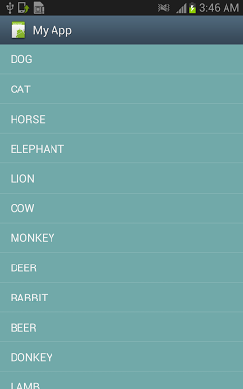](http://3.bp.blogspot.com/-69ktyPbsXrU/UaXfqpZJmcI/AAAAAAAAAXg/lpt5m9bMqb0/s1600/list.png)

**main.xml**

[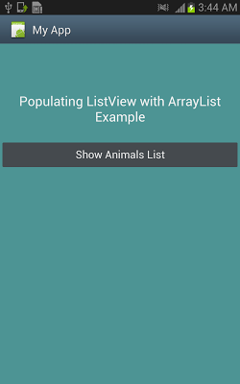](http://3.bp.blogspot.com/-NTldn_lDL28/UaXfqv3QF4I/AAAAAAAAAXo/dBPSdtqd5E8/s1600/list+main.png)

<LinearLayout  
    android:layout_width="fill_parent"   
    android:layout_height="fill_parent"   
    android:orientation="vertical"  
    android:background="#4D9494"  
    xmlns:android="http://schemas.android.com/apk/res/android">  
  
    <TextView  
        android:id="@+id/textView1"  
        android:layout_marginTop="80dp"  
        android:gravity="center_horizontal"  
        android:layout_width="fill_parent"  
        android:layout_height="wrap_content"  
        android:text="Populating ListView with ArrayList Example"  
        android:textAppearance="?android:attr/textAppearanceLarge" />  
  
    <Button  
       android:id="@+id/butttonShowAnimal"  
        android:layout_marginTop="25dp"  
        android:layout_width="fill_parent"  
        android:layout_height="wrap_content"  
        android:text="Show Animals List"   
        />  
      
  
</LinearLayout>

**animal_list.xml**

( For AnimalListActivity to show Animal Names, this layout contains only a ListView)

<LinearLayout xmlns:android="http://schemas.android.com/apk/res/android"  
    android:layout_width="match_parent"  
    android:layout_height="match_parent"  
    android:orientation="vertical" >  
      
    <ListView  
        android:id="@+id/listViewAnimals"  
        android:layout_width="fill_parent"  
        android:layout_height="fill_parent"   
        android:dividerHeight="0.1dp"  
        android:divider="#0000CC"  
        >  
    </ListView>  
      
</LinearLayout>

**MainActivity.java**

From this Activity when you click   Show Animals List , AnimalListActivty will start which showa the list of Animals.  
  
  
public class MainActivity extends Activity   
{  
          
    @Override  
    protected void onCreate(Bundle savedInstanceState)   
    {  
             super.onCreate(savedInstanceState);  
             setContentView(R.layout.main);  
               
                   // Get The Refference Of Button    
             Button btnShowAnimal=(Button)findViewById(R.id.buttonShowAnimal);  
                           
             
            // Set OnClick Listener on  button  and start AnimalListActivity when clicked on Button  
             btnShowAnimal.setOnClickListener(new View.OnClickListener() {  
                      
                    public void onClick(View v) {  
                        // TODO Auto-generated method stub  
                          
                        /// Create Intent for AnimalListActivity and Start The Activity  
                        Intent intentAnimalList=new Intent(getApplicationContext(),AnimalListActivity.class);  
                        startActivity(intentAnimalList);  
                    }  
                });  
    }  
}

**ShowAnimalsListActivity.java**

**(this Activity will inflate the animal_list layout and show  the List of Animals)**  
  
public class ShowAnimalsListActivity extends Activity  
{  
      
        ArrayList<String> animalsNameList;  
        public void onCreate(Bundle saveInstanceState)  
        {  
                super.onCreate(saveInstanceState);  
                setContentView(R.layout.animal_list);  
                  
               // Get the reference of ListViewAnimals  
                ListView animalList=(ListView)findViewById(R.id.listViewAnimals);  
                  
                  
                 animalsNameList = new ArrayList<String>();  
                 getAnimalNames();  
             **// Create The Adapter with passing ArrayList as 3rd parameter**  
                 ArrayAdapter<String> arrayAdapter =        
                 new ArrayAdapter<String>(this,android.R.layout.simple_list_item_1, animalsNameList);  
                 **// Set The Adapter**  
                 animalList.setAdapter(arrayAdapter);   
                   
               **// register onClickListener to handle click events on each item**  
                 animalList.setOnItemClickListener(new OnItemClickListener()  
                    {  
                             // argument **position** gives the index of item which is clicked  
                            public void onItemClick(AdapterView<?> arg0, View v,int position, long arg3)  
                            {  
                                  
                                    String selectedAnimal=animalsNameList.get(position);  
                                    Toast.makeText(getApplicationContext(), "Animal Selected : "+selectedAnimal,   Toast.LENGTH_LONG).show();  
                                 }  
                    });  
        }  
          
        void getAnimalNames()  
        {  
            animalsNameList.add("DOG");  
            animalsNameList.add("CAT");  
            animalsNameList.add("HORSE");  
            animalsNameList.add("ELEPHANT");  
            animalsNameList.add("LION");  
            animalsNameList.add("COW");  
            animalsNameList.add("MONKEY");  
            animalsNameList.add("DEER");  
            animalsNameList.add("RABBIT");  
            animalsNameList.add("BEER");  
            animalsNameList.add("DONKEY");  
            animalsNameList.add("LAMB");  
            animalsNameList.add("GOAT");  
              
              
        }  
}

[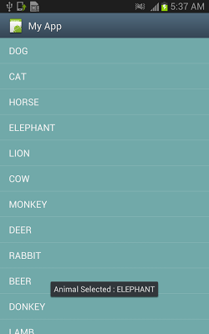](http://4.bp.blogspot.com/-sW1oLL67e0Y/UaXfqj0aggI/AAAAAAAAAXk/nMhz19NJgic/s1600/list+clicked.png)

**How to Populate ListView with DataBase**

[Populating ListView with DataBase](http://www.learnandroideasily.blogspot.in/2013/02/populating-listview-with-database.html)